

Created by

Jyoti Sharma

Nov 30, 2020

Advanced Database Management

Prof Jack Polnar

# Data Modeling and Migration



**Table of Contents**

Goal 4

How we are going to approach our goal 4

Dataset Information 4

Dataset Description 4

Dataset Attributes 5

Data Sources 6

Understanding the Datasets and differences 6

Data modeling practices 7

Differences in Relational and MongoDB (~NoSql) 7

Data Modeling Approach in MongoDB 8

Data Preprocessing 11

Application Analysis 14

Step 1: Describing the workload 15

Step 2: Identify the entities and relationship 16

In summary the way schema is designed every entity will have one-to-one relationships with the main entity JobInfo. 20

Step 3: Design Model and Apply patterns 20

Data Loading 24

Step 1: Generating documents using script 24

Step 2: Loading data into Mongo DB 25

Querying loaded data 27

Query 1: 27

Query 2: 29

Query 3: 30

Constraints 31

Write Durability 32

Bibliography 33

# **Goal**

This project aims to explore the best methods and operational practices to import data from flat file or relation DB systems to NoSql MongoDB.

As a part of this project, I have worked on

* Exporting data from CSV to MongoDB/JSON format.
* Understanding best practices of data modeling/schema designing.
* Migrating data to MongoDB.
* Understand best operational practices in MongoDB.

## How we are going to approach our goal

We will be using two datasets, data from different sources. The idea is first to understand the dataset and the differences in data modeling approaches in Relational databases and NoSql databases.

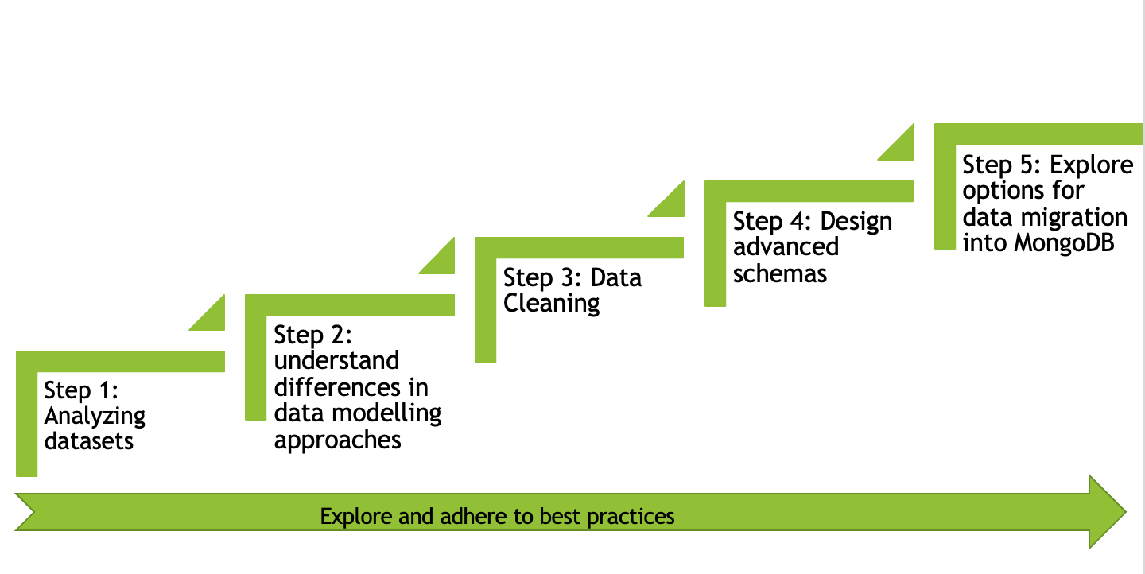

Fig: Path for achieving goals

# **Dataset Information**

## Dataset Description

I have used two different datasets downloaded from Kaggle.com. The datasets contain information about various job postings.

**Data Source 1: moster_com-job_sample.csv**

This data is an extract of job postings on monster.com- a job search website.

**Data Source 2: data_scientist_united_states_job_postings_jobspikr.csv**

This data contains information about multiple job postings for data scientist profiles across the United States and collections for different platforms like indeed, dice, monster, career builder, etc.

## Dataset Attributes

**Data Source 1: moster_com-job_sample.csv**

The below table consists of a description of all columns:

|  |  |  |
| --- | --- | --- |
| Fields | Description | Available in both datasets |
| country | The country name for a job opening | N |
| country_code | Abbreviation of Country name for the job opening | Y |
| date_added | The date of job posting | Y |
| has_expired | Is the job still open | N |
| job_board | The platform posting the job opening | Y |
| job_description | Description of the job profile | Y |
| job_title | Job position title | Y |
| job_type | Type of Job | N |
| location | Location | N |
| organization | Job category, describing if it's in accounting or biotech or banking | Y |
| page_url | URL of job posting | Y |
| salary | Salary Range | N |
| sector | The experience type for the job. | N |
| uniq_id | Uniquely identifying the job posting | N |

**Data Source 2: data_scientist_united_states_job_postings_jobspikr.csv**

The below table consists of a description of all columns:

|  |  |  |
| --- | --- | --- |
| Fields | Description | Available in both datasets |
| crawl_timestamp | The timestamp of extracting data from the job portal | N |
| URL | URL of job posting | Y |
| job_title | Job position title | Y |
| category | Job category, describing if it's in accounting or biotech or banking | Y |
| company_name | Name of the company | N |
| city | city area for the job position | N |
| state | State for the job position | N |
| country | Abbreviation of Country name for the job opening | Y |
| inferred_city | the city for the job position | N |
| inferred_state | State in which job is offered | N |
| inferred_country | The country in which job is open | Y |
| post_date | Date of job posting | Y |
| job_description | Description of the job profile | Y |
| job_type | Type of job contract Full/Part-time | N |
| salary_offered | Salary offered | Y |
| job_board | The site from which job post is fetched | Y |
| geo | Country name | N |
| cursor | Longitude and latitude of job location | N |
| contact_email | Contact person email | N |
| contact_phone_number | Contact person Phone | N |
| uniq_id | Unique id for the job posting | N |
| html_job_description | HTML code for Job description | N |

## Data Sources

https://www.kaggle.com/

## Understanding the Datasets and differences

Both datasets contain information about different job postings. There are some differences in both datasets and the fields to be implemented in the final implementation. Also, few fields are missing, will be required to add more fields.

**Fields to be Kept:**

|  |  |  |
| --- | --- | --- |
| Fields | *Description* | *Available in both datasets* |
| job_title | Job position title | Y |
| category | Job category, describing if it's in accounting or biotech or banking | Y |
| company_name | Name of the company | N |
| inferred_city | the city for the job position | N |
| inferred_state | State for the job position | N |
| inferred_country | County for the job position | Y |
| job_description | Description of the job profile | Y |
| post_date | Date in which job is posted | N |
| job_type | Type of job contract Full/Part-time | N |
| contact_email | Contact person email | N |
| contact_phone_number | Contact person Phone | N |
| job_board | site name posting the job | Y |
| salary | Salary Range offered | Y |
| has_expired | Is the job position currently open? | N |

**Additional Fields:**

|  |  |
| --- | --- |
| Fields | *Description* |
| RequiredQual | What is the minimum required qualification? |
| top skills | what are the top skills needed by end-users |

# **Data modeling practices**

## Differences in Relational and MongoDB (~NoSql)

MongoDB's design philosophy is to combine the critical capabilities of relational databases and innovative NoSql technologies. The vision is to leverage Oracle and others' work over the last 40 years to make relational databases what they are today. Rather than discard decades of proven database maturity, MongoDB picks up where they left off by combining key relational database capabilities with Internet pioneers' work to address modern applications' requirements [11].

## Data Modeling Approach in MongoDB

One of the critical differences between relational and MongoDB is the idea based on which cluster/table structure is defined. Where relation DBMS focuses on how data is stored, NoSql focuses on data retrieval pattern by applications. Unlike in relational DBMS in MongoDB, the documents are designed keeping in mind how it is retrieved, paying a little or no attention towards normalization.

**Advantages of NoSQL**

* **Flexible Schema**

Unlike relation SQL databases, where you must determine the and declare table schema before inserting data, MongoDB’s collection by default doesn’t require its document to have a schema. That is:

* Documents of a single collection need not have the same set of fields. The data type for fields can differ across documents within the collection. [2]
* To change the documents' structure in a collection like adding a new field, remove an existing field, or change field values to a new type, update the documents to a new structure. [2]

This flexibility helps in mapping a document to an object or entity. Each document can match the represented entity's field, even if it has substantial document variation from other collection documents. [2]

However, the latest version of MongoDB also gives the option of enforcing schema/document validation rules. The schema validation can be implemented using a JSON schema validator supported by MongoDB.

For example, the following example specifies validator rules using the query expression:

db.createCollection( "contacts",

{ validator: { $or:

[

{ phone: { $type: "string" } },

{ email: { $regex: /@mongodb\.com$/ } },

{ status: { $in: [ "Unknown", "Incomplete" ] } }

]

}

} )

Ref took from [3]

It provides constraints on format of email field it should end with @mongodb.com, also the value of status field should be either ‘Unknown’ Or ‘Incomplete’.

To control the scope of validation implementation, MongoDB also provides the following related options:

* **validationLevel option**: This determines how strictly MongoDB applies validation rules to existing documents during an update. There are two possible values strict or moderate. Strict is the default behavior.
  1. strict (the default) MongoDB applies validation rules to all inserts and updates.
  2. moderate applies validation rules to inserts and to updates to existing documents that already fulfill the validation criteria
* **validationAction option**: which determines whether MongoDB should error and reject documents that violate the validation rules or warn about the log's violations but allow invalid documents. There are two possible values error (the default) or warn. If set to error it will reject any insert or updates that violates the validation criteria, whereas warn will log but allow insert of documents. [3]
  1. error (the default), MongoDB rejects any insert or update that violates the validation criteria.
  2. warn, MongoDB logs any violations but allows the insertion or update to proceed.
* **Document structure**

The primary focus in data model designing for MongoDB application is focused on documents' structure and how the application represents relationships between data. MongoDB two ways to organize the data via **embedding** and **linking**.

* + **Embedding:**

Embedding helps documents by capturing relationships between data in a single document store. This schema is also referred as a denormalized data model. It is used to depict

* One to one relationship
* One to many relationships

In general, embedding provided better performance for reading operations and the ability to request and retrieve related data in a single database operation. One restriction is the document size; there is a limit of 16MB on MongoDB documents.

* + **Linking/References:**

Linking/References stores the relationship between data by including links and references to another document. Applications can use the references to access the related data. This is also referred to as the Normalized version.[2]

MongoDB applications use one of two methods for relating documents:

* Manual references
* DBRef’s

**Manual reference** is the practice of including one document _id field into another. The application can take the _id and query the second document.

original_id = ObjectId()

db.places.insert({

"_id": original_id,

"name": "Broadway Center",

"url": "bc.example.net"

})

db.people.insert({

"name": "Erin",

"places_id": original_id,

"url": "bc.example.net/Erin"

})

Example is taken from the MongoDB Manual

However, **DBRef’s** maintains the reference by using three fields

* + $ref
  + $id
  + $db

Where $db is usually optional.

* **Atomicity of write operations**
* **Single Document Atomicity**

In MongoDB, atomicity is at the document level, even if the operation modifies multiple documents embedded within the single document.[2]

* **Multi-Document Transactions**

From version 4.2 onwards, MongoDB introduces distributed transactions, which adds support for multi-document transactions on sharded clusters and incorporates the existing support for multi-document transactions on replica sets. The atomicity of multi-document transactions is maintained by below

* all-or-nothing: In case of multiple document transactions, it will either commit/rollback all transactions or none.
* In a situation where a transaction is aborted, all the data changes made by the transaction are discarded. [14]
* **Data Use and Performance**

In MongoDB, one of the primary focuses is on how your application is going to behave. If the applications use only recently introduced document, then **Capped Collections** usage can be considered.[2]

Few operational considerations that might affect the data designs are

* Sharding
* Indexes
* A large number of collections or Collection containing a large number of documents
* Storage optimization for large documents
* Data Life Cycle Management

Best design practices in MongoDB considers the above-mentioned facts before deciding on the data schema design.

# **Data Preprocessing**

For any data migration activity preprocessing the data plays a critical role. Below are the snapshots of both datasets

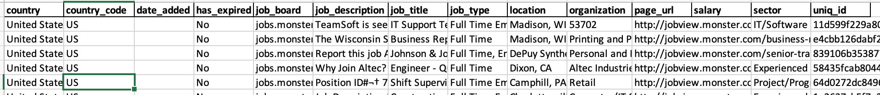

Snapshot of the **monster_com-job_sample** dataset

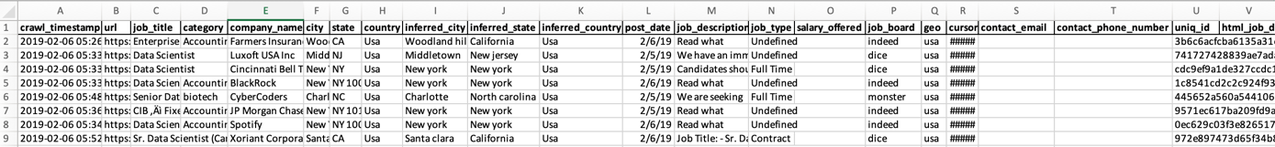

Snapshot of **data_scientist_united_states_job_postings_jobspikr** dataset

As a part of preprocessing, I have performed the below steps

* **Deciding on the final fields**

Both data files contain some additional fields that might not be required for the target application I have performed data modeling. So, we have removed a few columns and added some to bring both the datafiles in sync. The final data frame will consist of the below fields

|  |  |
| --- | --- |
| Fields | Description |
| country_code | Abbreviation of Country name for the job opening |
| Date_added | Date in which job is posted |
| has_expired | Is the job still open |
| job_board | The site on which job is posted |
| job_description_Abstract | Trimmed description of the job profile |
| job_description | Description of the job profile |
| job_title | Job position title |
| job_type | Type of job contract Full/Part-time/contract |
| City | City in which job is offered |
| State | State in which job is offered |
| sector | Which field the job belongs to Medical or IT Or Marketing |
| JobPostingLink | Link of job posted |
| salary | Salary range offered |
| TopSkills* | The top skill required for the job |
| MinRequiredQual* | Minimum qualification required to apply for the job |
| CompanyName | Company name |

**\*Newly added fields**

* **Cleaning of data**

Since the dataset are obtained from the web scraping process, the data consist of many junk characters like “﻿¬†>‚Ä¢”. So as a part of the cleaning process, I have applied the cleaning function to remove the junk characters from job_description, ﻿job_type, ﻿organization, ﻿country,inferred_city, ﻿inferred_state, ﻿category, company_name fields of original datasets before merging them into the clean dataset. I have written a python script ‘CleaningScript.py’ to perform cleaning and merging of the datasets. Below is the snippet of the string clean function.

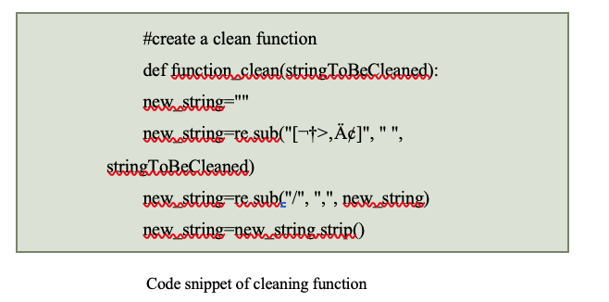

* **Extracting data fields from a single string**

In the monster job data set, the details of city and state are merged in one single column. As a part of the cleaning process and bringing both datasets in sync, I have written a function for parsing the string and extract the data needed.

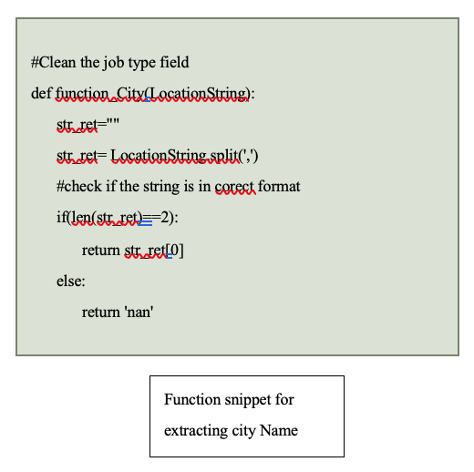

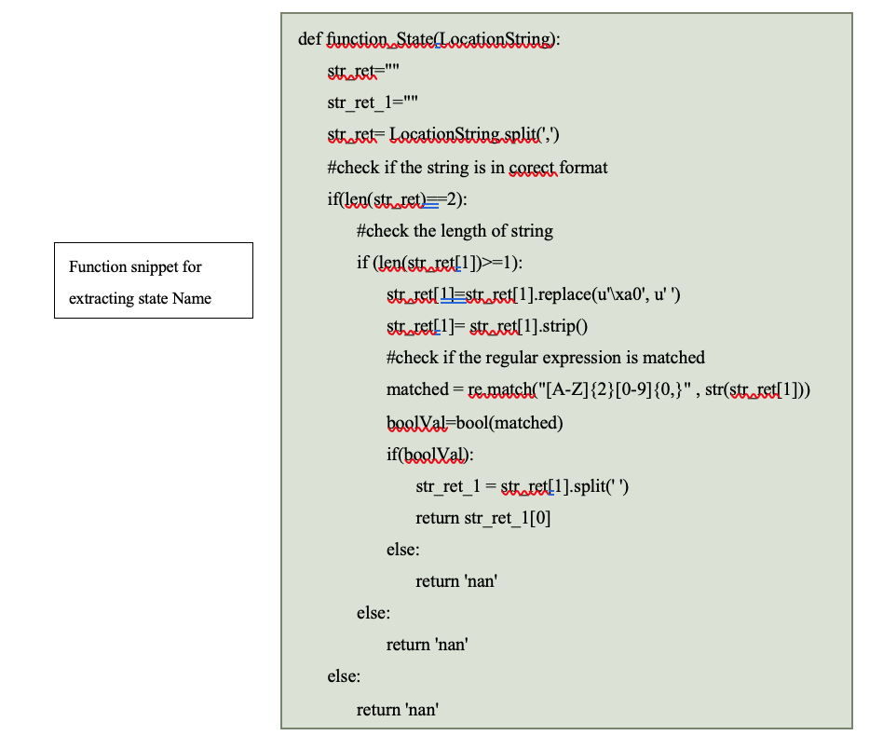

* **Merging the datasets**

After cleaning, both datasets are merged into a single data frame, ‘CleanDataSet.csv’. The data modeling process will be carried out on this dataset.



Snapshot of Merged Dataset

**Cleaning script execution**

Below are the specifics of the script used for data cleaning purpose

**Tool Used:** Spyder

**Programming Language:** Python

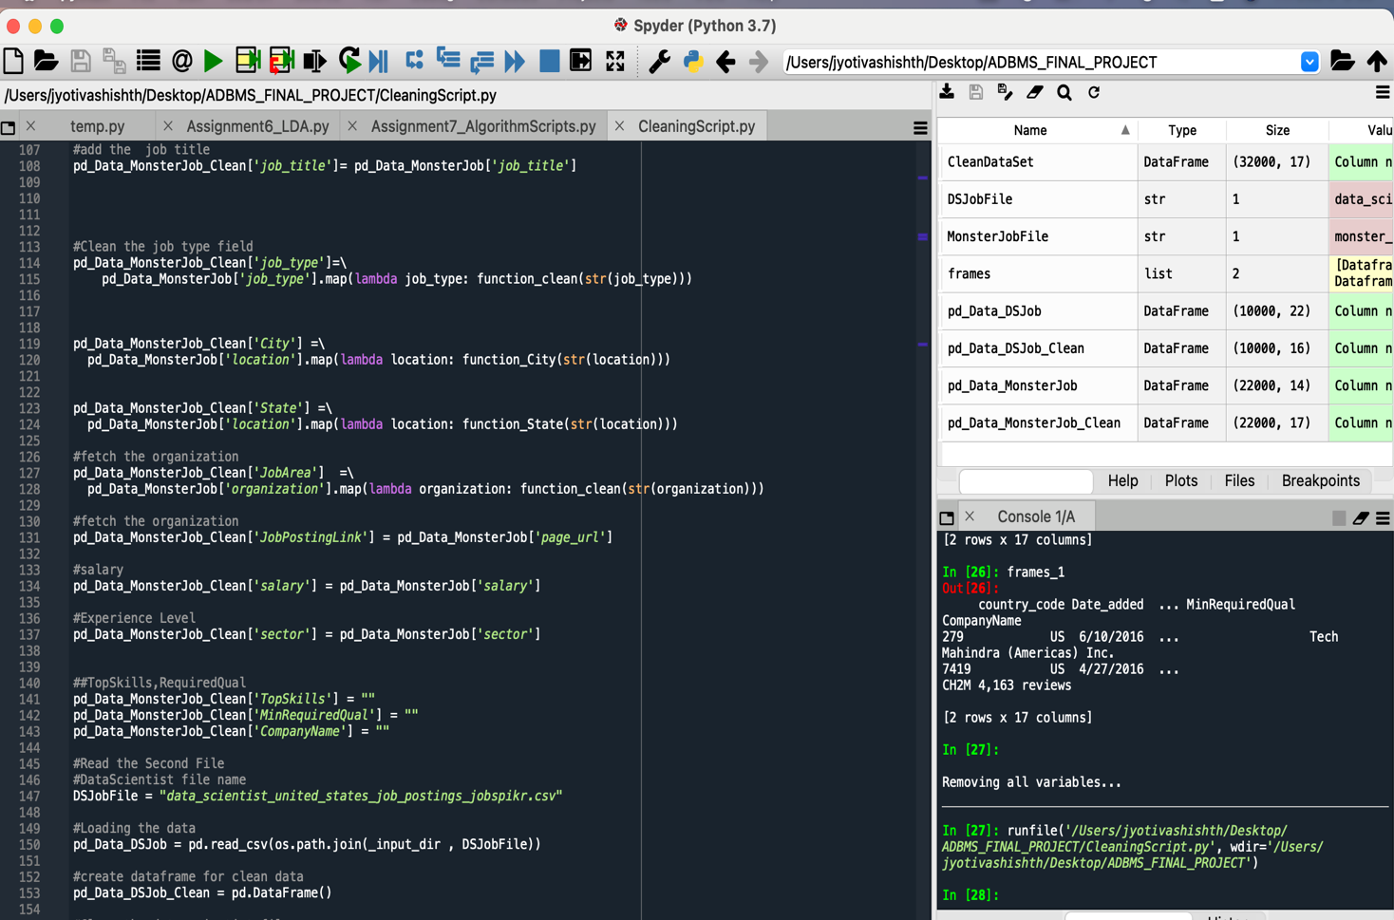

Fig: Screenshot of Python cleaning script execution

# **Application Analysis**

One of the primaries focuses on data modeling in MongoDB is to understand the application queries.

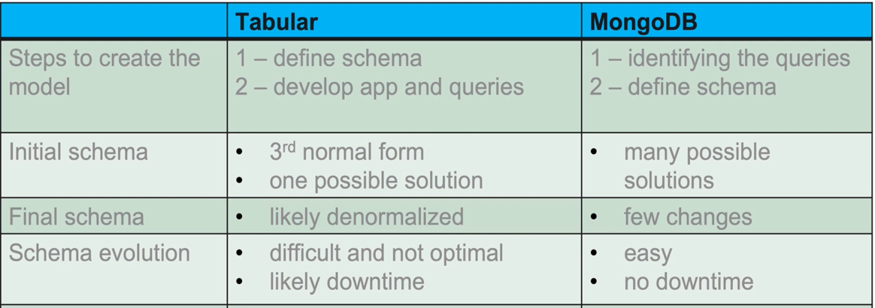

Summary of differences between Tabular and MongoDB [17]

The MongoDB while implementing an ideal methodology, one should follow the below steps

Step 1: Describing the workload

Step 2: Identify the entities and relationship

Step 3: Design model and apply patterns

## Step 1: Describing the workload

I have aimed to design the MongoDB schema for an entry-level job portal, which collects data from multiple job search platforms and shows the job openings inside the USA at one go. This is a one-stop solution for job hunting needs.

**Name of System:** One-Click Job Search

**Benefits:** The main goal of developing this system is to have a centralized job search platform. They are helping end-users to save time in the tedious job hunt process. The schema designing process will begin with describing the workload, look for the most frequent operations which will be performed by the application.

List of operations:

Below is the list of operations to be implemented in the application

|  |  |  |
| --- | --- | --- |
| Query | Operation | Description |
| 1. Search the job postings based on job title or a substring of job title. | Read | Lookup for jobs with keywords or full job title. |
| 2. Search the job posting based on the company name. | Read | Look for jobs based on the name of the company in which the position is open. |
| 3. Search the job posting based on State name. | Read | Look for jobs based on the state name in which the job position is opened. |
| 4. Read the full job description. | Read | Look up the full job description for the job post of interest. |
| 5. Updating the jobs | Write | Update a job posting in the system, adding a new job posting, or marking a job posting a closed. |
| 6. Search the job posting based on skills required | Read | Lookup for a job-based on the skills job requires. |

Workload quantify/qualify operation:

Below is the summary of the quantification and qualification of the most frequent operations in the initial implementation.

|  |  |  |
| --- | --- | --- |
| Query | Quantification | Qualification |
| 1. Search the job postings based on job title or a substring of job title. | Retrieval time < 1 s | No stale data  <Critical Operation> |
| 2. Search the job posting based on the company name. | Retrieval time < 1 s | No stale data  <Critical Operation> |
| 3. Search the job posting based on State name. | Retrieval time < 1 s | No stale data  <Critical Operation> |
| 4. Read the full job description. | Retrieval time < 3 s | No stale data |
| 5. Updating the jobs | Write time < 0.05s per transaction | critical write |
| 6. Search the job posting based on skills required | Retrieval time < 3 s | No stale data |

## Step 2: Identify the entities and relationship

In the process of identifying models and relationships, the first step is to identify the entities.

**Entities:**

After analyzing the data and the goals, I have come with the below entities

* **JobInfo**: This entity will consist of information that helps describe the job or give details about the job.
* **JobPostingInfo:** This entity will consist of information that helps describe which website the job posting came from and what date it will be available.
* **LocationInfo:** This entity will consist of information that helps describe the location of job openings like the city, state, and country.
* **JobCategory:** This entity will consist of information that helps describe the job posting's domain type.
* **JobRequirements:** This entity will consist of information that helps describe the job posting's skill and minimum education requirements.

All the fields of these entities are not normalized; for example, TopSkills field in entity **JobRequirements** can be further denormalized. TopSkills field will contain multiple skills required for the job like c programming, HTML, .Net, Java, python etc.

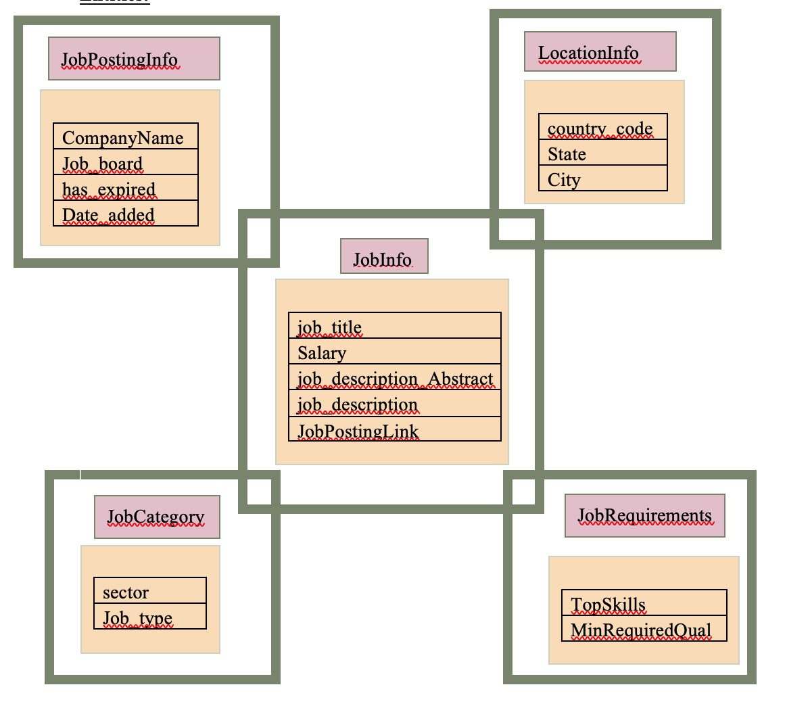

Fig: Multiple entities

The entities derived are not in normalized form, but that’s the beauty of the NoSQL system. We can create documents as per our needs.

**Data example**

Below is data for one row for all entities

**JobInfo**

|  |  |
| --- | --- |
| ROW ID | 1 |
| job_title | IT Support Technician Job in Madison |
| salary | IT/Software Development |
| job_description_Abstract | TeamSoft is seeing an IT Support Specialist to join our client in Madison, WI. The ideal candidate must have at least 6 years of experience in the fie... |
| job_description | b"TeamSoft is seeing an IT Support Specialist to join our client in Madison, WI. The ideal candidate must have at least 6 years of experience in the field. They need to be familiar with a variety of the field's concepts, practices, and procedures as this position relies on extensive experience and judgment to plan and accomplish goals. Required Skills: Call tracking software Phone based technical support Problem documentation and communication Remote Desktop Management Tools Respond to customer requests General understanding of LANDesk Microsoft Office 2007 SuiteFind out why TeamSoft is the Madison area's technology leader with over 200 IT consultants. Owned, operated, and managed by IT consultants, TeamSoft is the clear choice for your career. Join the TeamSoft family today!Did you know? TeamSoft offers salaried options for many positions that include 5 weeks PTO and great benefits! TeamSoft has been in business since 1996 TeamSoft's owners are local IT professionals who possess a wealth of experience in application development, business analysis, and project management TeamSoft's Recruiters are knowledgeable, friendly, and ready to help you make your next great career move TeamSoft offers a full benefits suite to all of our W2 consultants, including a 401k plan with a 100% vested 4% dollar for dollar match Our targeted selection process is designed to get to know your strengths and career interests and provide you with the best chance for success in your new position Our longest running consultant has been with us for 16 years Consultants can participate in our charitable giving committee. To date, TeamSoft's charitable giving committee has donated over $100,000!TeamSoft is owned by local IT professionals. Our team also has deep experience with IT staffing. Our clients understand this and rely on our expertise. That is why TeamSoft is the Madison Area's largest privately owned IT consulting firm, with more than 200 current consultants! With over 50 active clients, TeamSoft will give you the greatest exposure to the widest range of IT careers.Our owners possess a combined 60+ years of IT consulting experience. Our recruiting and Account Management staff are very well-versed in our client markets. We get you. We know you. We know what you do every day. And we know what you deal with on the job.You take your career seriously and so do we. At TeamSoft you are not just a resume or number. Our goal is to create long-term partnerships with each of our consultants, and according to feedback from many of them, we are very good at this. Click HERE to see what our consultants have to say about working with TeamSoft.TeamSoft -- Promote yourself!TeamSoft is an equal employment opportunity employer functioning under an Affirmative Action Plan." |
| JobPostingLink | http://jobview.monster.com/it-support-technician-job-madison-wi-us-167855963.aspx?mescoid=1500134001001&jobPosition=20 |

**JobPostingInfo**

|  |  |
| --- | --- |
| ROW ID | 1 |
| CompanyName |  |
| job_board | monster |
| has_expired | No |
| Date_added |  |

**LocationInfo**

|  |  |
| --- | --- |
| ROW ID | 1 |
| country_code | US |
| City | Madison |
| State | WI |

**JobCategory**

|  |  |
| --- | --- |
| ROW ID | 1 |
| sector | IT/Software Development |
| job_type | b'Full Time Employee' |

**JobReqirements**

|  |  |
| --- | --- |
| ROW ID | 1 |
| TopSkills |  |
| MinRequiredQual |  |

In this scenario

* **JobInfo** entity will have **one-to-one relationships** to **LocationInfo**, as each job posting will have one city, one state, and one job associated with it.
* **JobInfo** entity will have **one-to-one relationships with** **JobPostingInfo,** as each job posting will have one company name, one job board, date, and an expired flag associated with it.

## In summary the way schema is designed every entity will have one-to-one relationships with the main entity JobInfo.

## Step 3: Design Model and Apply patterns

For designing I Based on the frequent operations, entities and relationships embed all documents inside the JobInfo document can be a design choice to cater our needs.

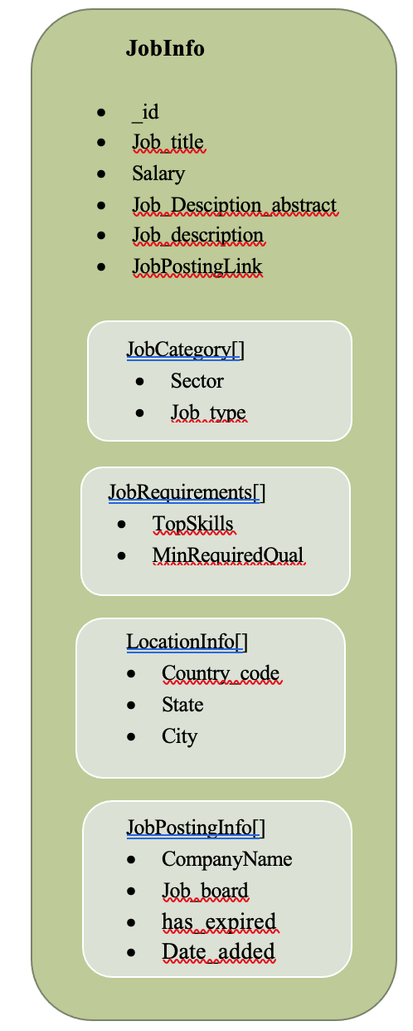

Fig: Displaying the embed all design – DesignVersion 1.0

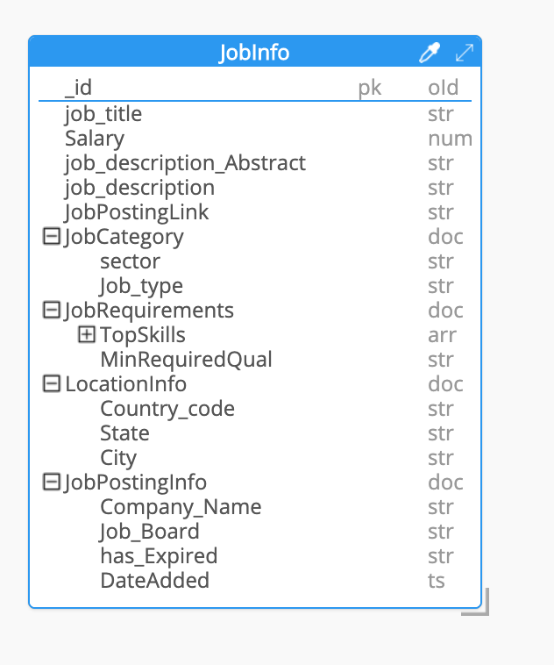

Fig: ER design for Version 1_0

 MongoDB Script generated by Hackolade tool

 JobInfo JSON Data syntax generated by Hackolade tool

Based on the current list of operations this design should serve the purpose, however there are few constraints and possible challenges that might occur. Below is the list of challenges that might occur

1. Job description field: This field contains vary long strings and one of the constraints in MongoDB is its document limit. So, it will make sense to move the job_description field into another cluster and link it to the existing one. In this design the job_description_abstract(~only contains 153 char) will give an overview of job.

Possible future requirements:

The model can be further enhanced by adding some schema design patterns in it.

1. Schema Versioning pattern:

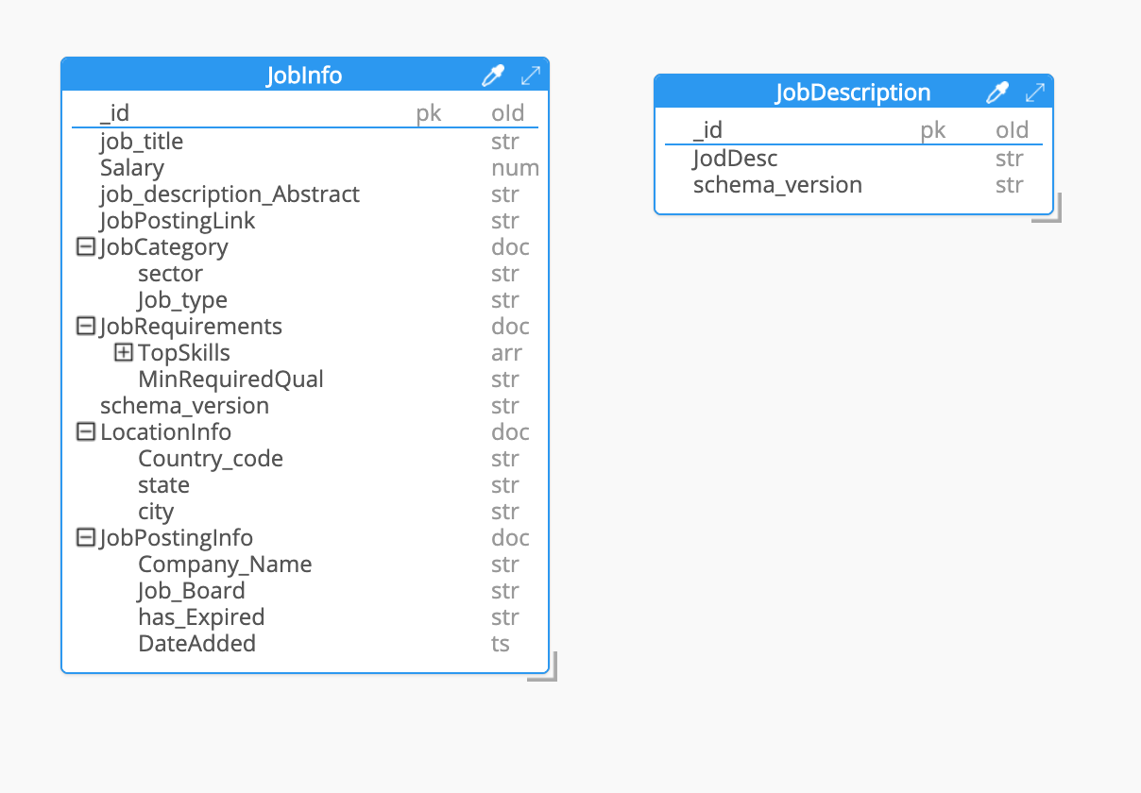

Fig: ER design for Version 1_1

 JobInfo MongoDB Script generated by Hackolade tool

 JobDescription MongoDB Script generated by Hackolade tool

 JobInfo JSON Data syntax generated by Hackolade tool

 JobDescription JSON Data syntax generated by Hackolade tool

# **Data Loading**

## Step 1: Generating documents using script

NoSQL schema requires a specific format for data. For creating the insert file, I have created a python script. The python script takes the clean data from “CleanDataSet.csv” file and generates two json files

i. JobDescription_new_insert.json file containing document for JobDescription collection.

ii. JobinfoList_new_insert.json file containing document for JobInfo collection.

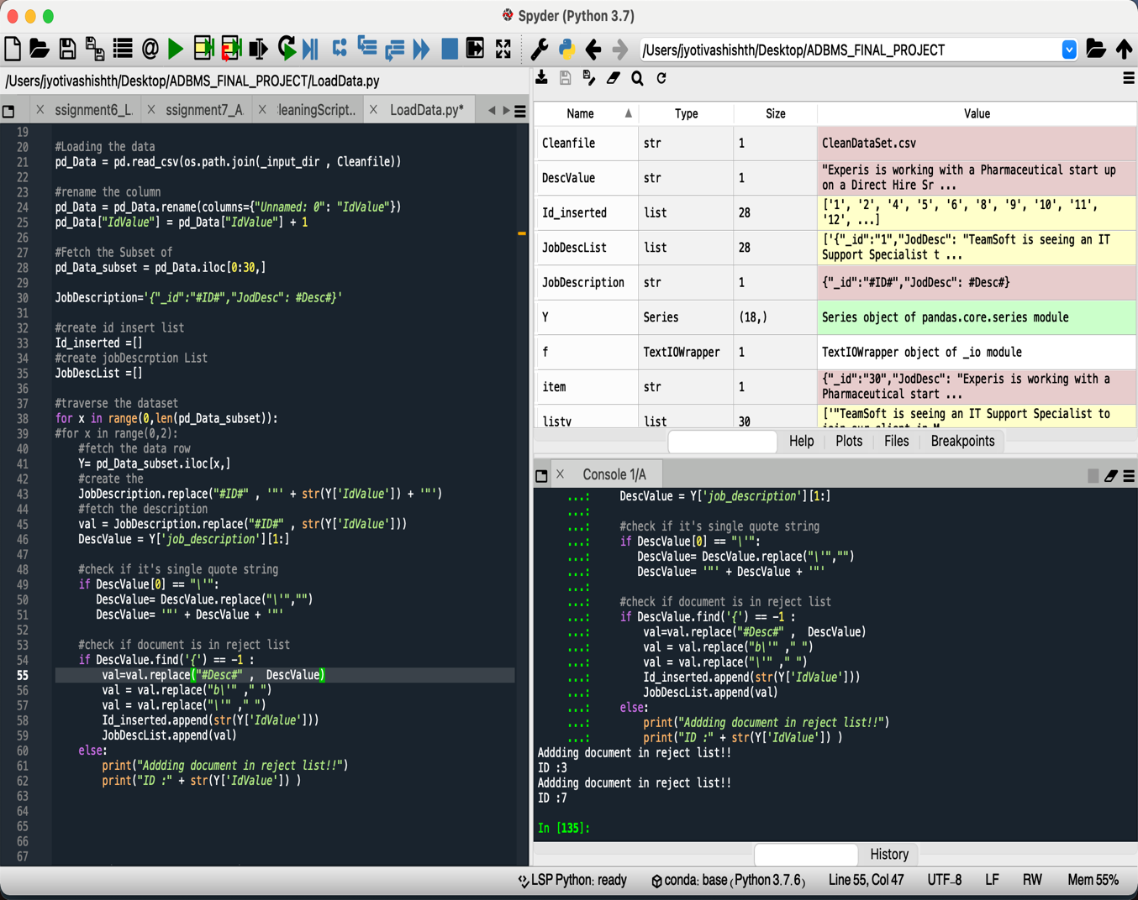

Fig: Execution screenshot of LoadData script

This script is traversing and generating documents and creating a reject list if in case any record doesn’t pass the syntax checks and reject it. In the end it will also display the id of rejected records.

## Step 2: Loading data into Mongo DB

The output files generated by ‘LoadData.py’ script ‘JobDescription_new_insert.json’ and ‘JobinfoList_new_insert.json’. These files are uploaded using MongoDB compass to insert documents inside collection.

Fig: Upload JobDescription documents

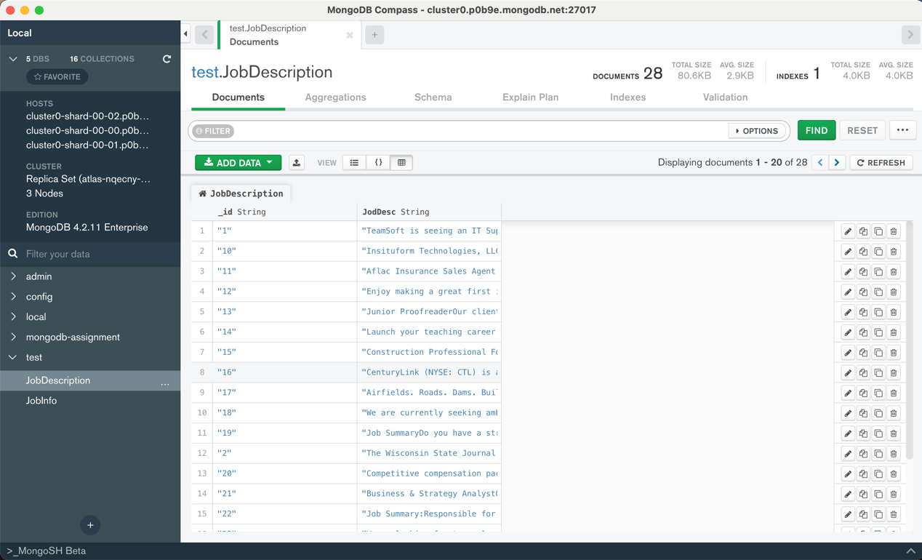

Fig: Validating uploaded JobDescription documents

Fig: Upload JobInfo documents

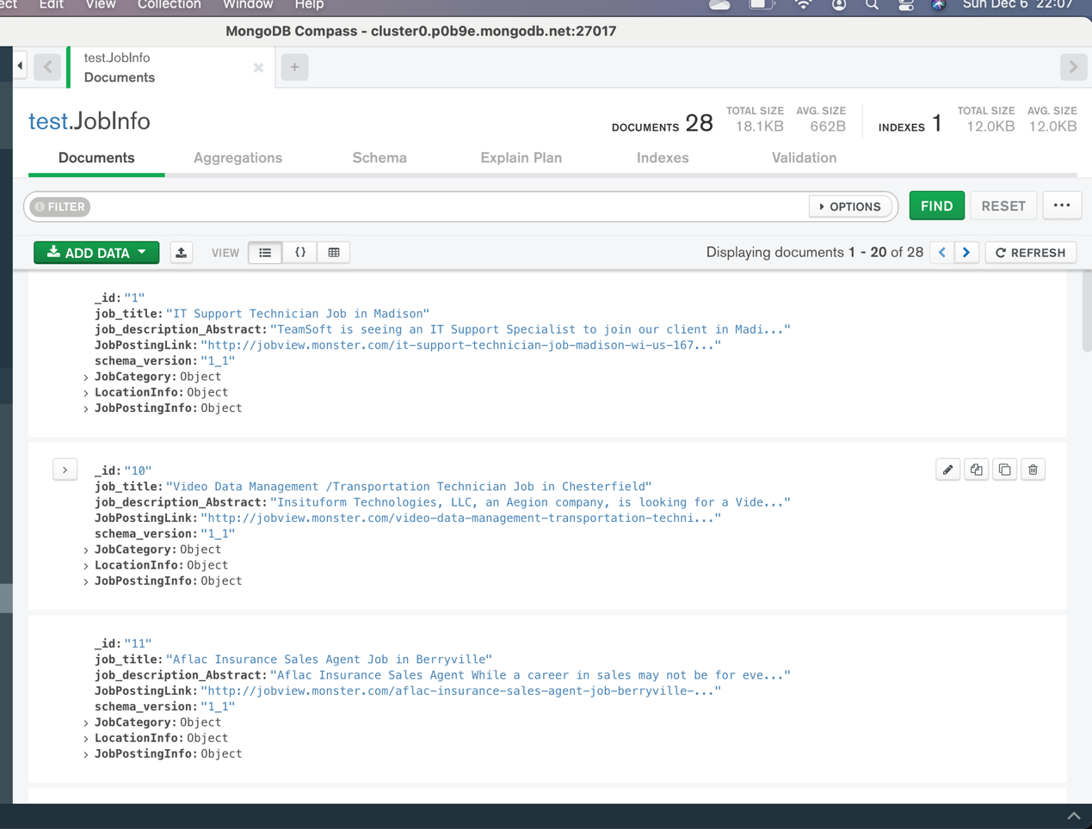

Fig: Validating uploaded JobInfo documents

# **Querying loaded data**

MongoDB compass also provides you with MongoDB shell. I have used MongoDB shell to query data from MongoDB collection created

## Query 1:

Joining jobInfo and JobDescription based on _id fields in both collections

**MongoDB Query:**

db.getCollection('JobInfo').aggregate([{

$lookup:{

from: "JobDescription",

localField: "_id",

foreignField : "_id",

as: "studentUnits"

}}])

**Result Screenshot:**

[ { _id: '1', job_title: 'IT Support Technician Job in Madison', job_description_Abstract: 'TeamSoft is seeing an IT Support Specialist to join our client in Madison, WI. The ideal candidate must have at least 6 years of experience in the fie...', JobPostingLink: 'http://jobview.monster.com/it-support-technician-job-madison-wi-us-167855963.aspx?mescoid=1500134001001&jobPosition=20', schema_version: '1_1', JobCategory:{ sector: 'IT/Software Development', Job_type: 'Full Time Employee' }, LocationInfo: { Country_code: 'US', state: 'WI', city: 'Madison' }, JobPostingInfo: { Job_Board: 'monster', has_Expired: 'No' }, studentUnits: [ { _id: '1', JodDesc: 'TeamSoft is seeing an IT Support Specialist to join our client in Madison, WI. The ideal candidate must have at least 6 years of experience in the field. They need to be familiar with a variety of the field s concepts, practices, and procedures as this position relies on extensive experience and judgment to plan and accomplish goals. Required Skills: Call tracking software Phone based technical support Problem documentation and communication Remote Desktop Management Tools Respond to customer requests General understanding of LANDesk Microsoft Office 2007 SuiteFind out why TeamSoft is the Madison area s technology leader with over 200 IT consultants. Owned, operated, and managed by IT consultants, TeamSoft is the clear choice for your career. Join the TeamSoft family today!Did you know? TeamSoft offers salaried options for many positions that include 5 weeks PTO and great benefits! TeamSoft has been in business since 1996 TeamSoft s owners are local IT professionals who possess a wealth of experience in application development, business analysis, and project management TeamSoft s Recruiters are knowledgeable, friendly, and ready to help you make your next great career move TeamSoft offers a full benefits suite to all of our W2 consultants, including a 401k plan with a 100% vested 4% dollar for dollar match Our targeted selection process is designed to get to know your strengths and career interests and provide you with the best chance for success in your new position Our longest running consultant has been with us for 16 years Consultants can participate in our charitable giving committee. To date, TeamSoft s charitable giving committee has donated over $100,000!TeamSoft is owned by local IT professionals. Our team also has deep experience with IT staffing. Our clients understand this and rely on our expertise. That is why TeamSoft is the Madison Area s largest privately owned IT consulting firm, with more than 200 current consultants! With over 50 active clients, TeamSoft will give you the greatest exposure to the widest range of IT careers.Our owners possess a combined 60+ years of IT consulting experience. Our recruiting and Account Management staff are very well-versed in our client markets. We get you. We know you. We know what you do every day. And we know what you deal with on the job.You take your career seriously and so do we. At TeamSoft you are not just a resume or number. Our goal is to create long-term partnerships with each of our consultants, and according to feedback from many of them, we are very good at this. Click HERE to see what our consultants have to say about working with TeamSoft.TeamSoft -- Promote yourself!TeamSoft is an equal employment opportunity employer functioning under an Affirmative Action Plan.', schema_version: '1_1' } ] }

## Query 2:

Fetching the unique Job_type and fetch the count of no of positions opened in each Job_type.

**MongoDB Query:** Fetching distinct Job_Type values loaded into documents

db.JobInfo.aggregate([{$unwind:"$JobCategory"},{$group:{_id:"$JobCategory. Job_type"}}])

**Result Screenshot:**

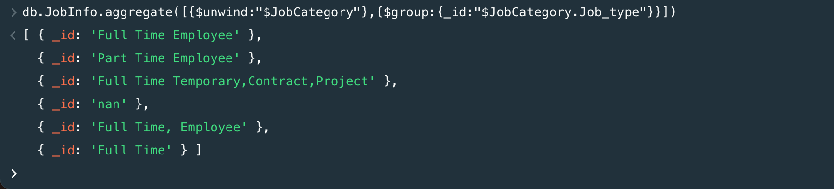

**MongoDB Query:** Fetching distinct Job_Type values along with their count for loaded into documents.

**MongoDB Query:**

db.JobInfo.aggregate([

{ "$unwind": "$**JobCategory**" },

{ "$group": { "_id": "$**JobCategory**.Job_type ",

"count": { "$sum": 1 }

}}

])

**Result Screenshot:**

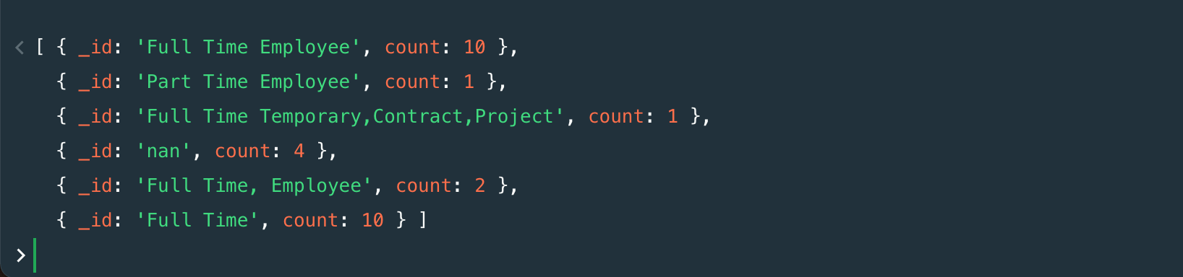

## Query 3:

Fetching the unique cities and fetch the count of no of positions opened in each city.

**MongoDB Query:** Fetching distinct city values loaded into documents

db.JobInfo.aggregate([{$unwind:"$LocationInfo"},

{$group:{_id:"$LocationInfo.city"}}])

**Result Screenshot:**

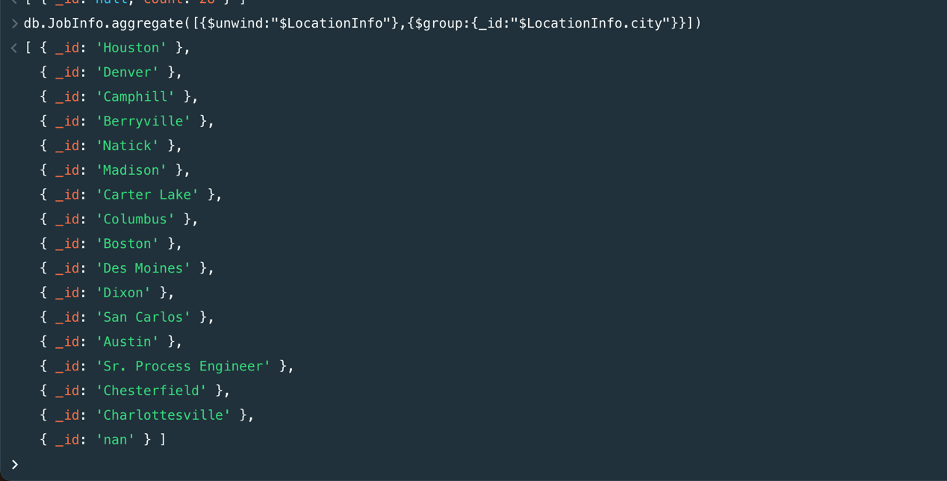

**MongoDB Query:** Fetching distinct city values loaded into documents along with count

db.JobInfo.aggregate([

{ "$unwind": "$LocationInfo" },

{ "$group": { "_id": "$LocationInfo.city",

"count": { "$sum": 1 } }} ])

**Result Screenshot:**

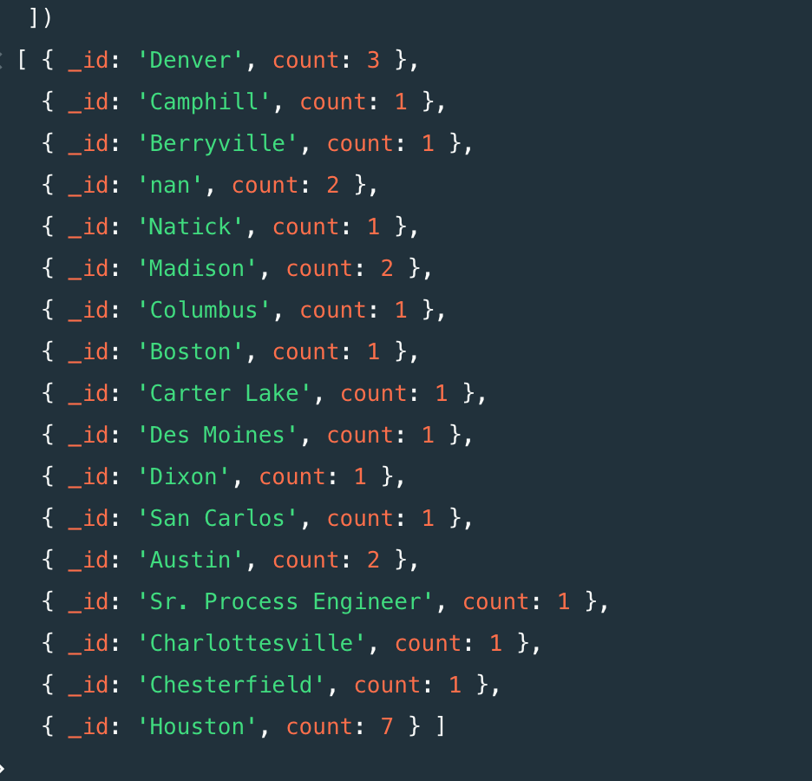

# **Constraints**

Below are few constraints on MongoDB implementation and should be considered while implementing schema in MongoDB

* By default, MongoDB will automatically abort any multi-document transaction that runs for more than 60 seconds.[16]
* There are no hard limits to the number of documents that can be read within a transaction. As a best practice, no more than 1,000 documents should be modified within a transaction.[16]
* In MongoDB 4.0, a transaction is represented in a single oplog entry, therefore must be within the 16MB document size limit. If this limit is exceeded, the transaction will be aborted and fully rolled back. The transaction should therefore be decomposed into a smaller set of operations that can be represented in 16MB or less.[16]

# **Write Durability**

MongoDB uses write concerns to control the level of write guarantees for data durability.

With stronger write concerns, write operations wait until MongoDB applies and acknowledges the operation.

With stronger write concerns, write operations wait until MongoDB applies and acknowledges the operation. This is MongoDB’s default configuration. The behavior can be further tightened by also opting to wait for replication of the write to:

• A single secondary

• A majority of secondaries

• A specified number of secondaries

• All of the secondaries – even if they are deployed in different data centers (users should evaluate the impacts of network latency carefully in this scenario) .[16]

# Bibliography

1.) https://www.mongodb.com/blog/post/transitioning-from-relational-databases-to-mongodb

2.) <https://docs.mongodb.com/manual/core/data-modeling-introduction/>

3.) <https://docs.mongodb.com/manual/core/schema-validation/>

4.) <https://docs.mongodb.com/manual/reference/database-references/>

5.) <https://www.mongodb.com/presentations/data-modeling-with-mongodb>

6.) <https://www.mongodb.com/presentations/advanced-schema-design-patterns>

7.) <https://docs.mongodb.com/manual/reference/sql-aggregation-comparison/>

8.) <https://docs.mongodb.com/manual/reference/sql-comparison/>

< performing common operations like update/inserts>

9.) <https://docs.mongodb.com/manual/reference/operator/aggregation/>

< Examples of mathematical operations >

10.) <https://docs.mongodb.com/master/core/transactions/>

< API for performing transactions>

11.) https://www.mongodb.com/scale/relational-vs-non-relational-database

12.) <https://docs.mongodb.com/manual/core/data-model-design/#data-modeling-embedding>

13.) <https://docs.mongodb.com/manual/reference/database-references/#document-references>

14.) https://docs.mongodb.com/manual/core/transactions/

**White Paper:**

15.) MongoDB_operations_best_practices-iksgd9n62y.pdf, published by MongoDB

16.) RDBMStoMongoDBMigration.pdf, published by MongoDB

**MongoDB Tutorials:**

17.) A Complete Methodology of Data Modeling for MongoDB

<https://www.youtube.com/watch?v=DUCvYbcgGsQ>

18.) Data Modeling with MongoDB

<https://www.youtube.com/watch?v=yuPjoC3jmPA>

19.) Advanced Schema Design Patterns

https://www.youtube.com/watch?v=bxw1AkH2aM4